**Load Testing Report using JMeter**

**Http Header Manager Screenshot:**

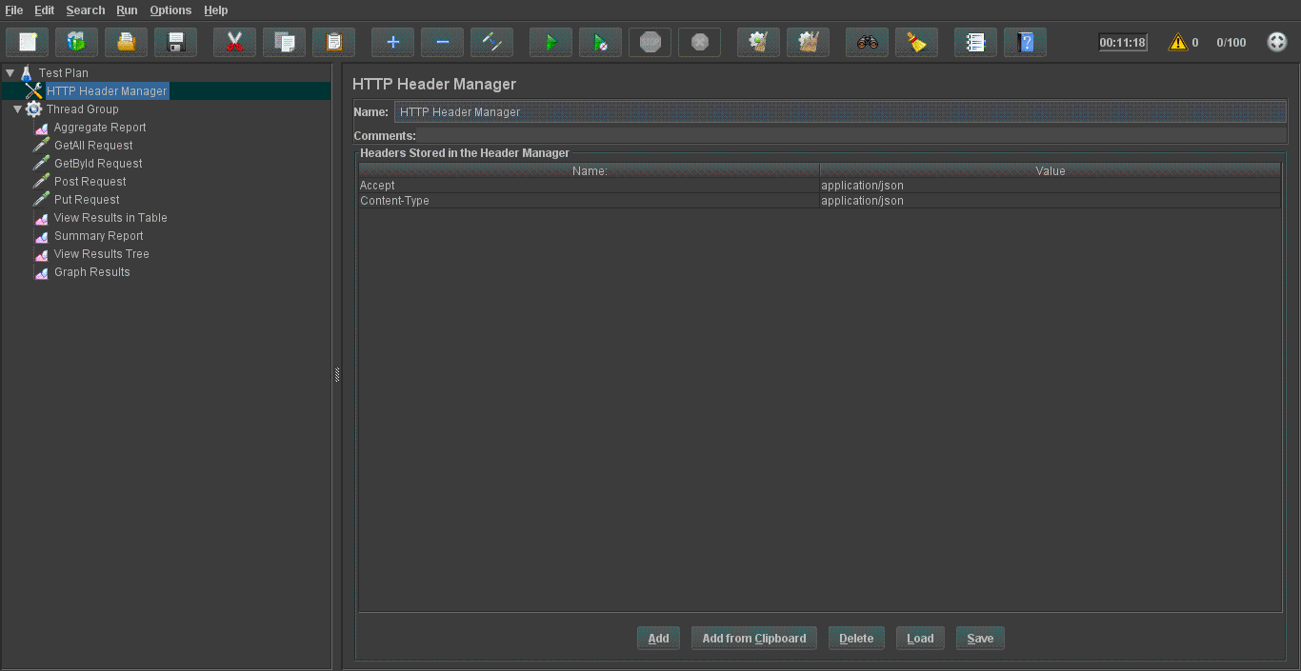

**Thread Group:**

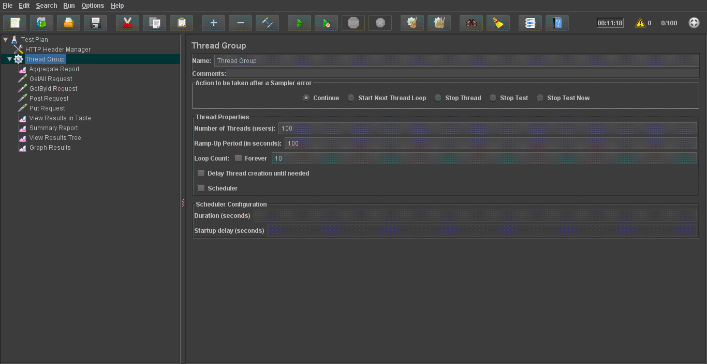

**GetAllHttp Request:**

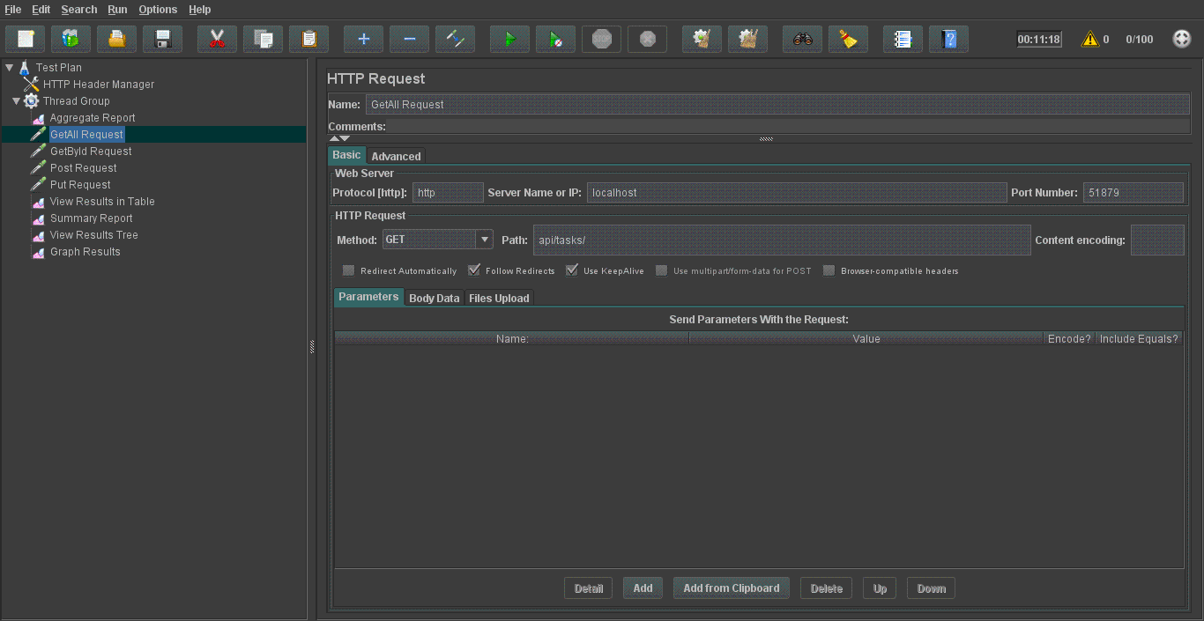

**GetByIdRequest:**

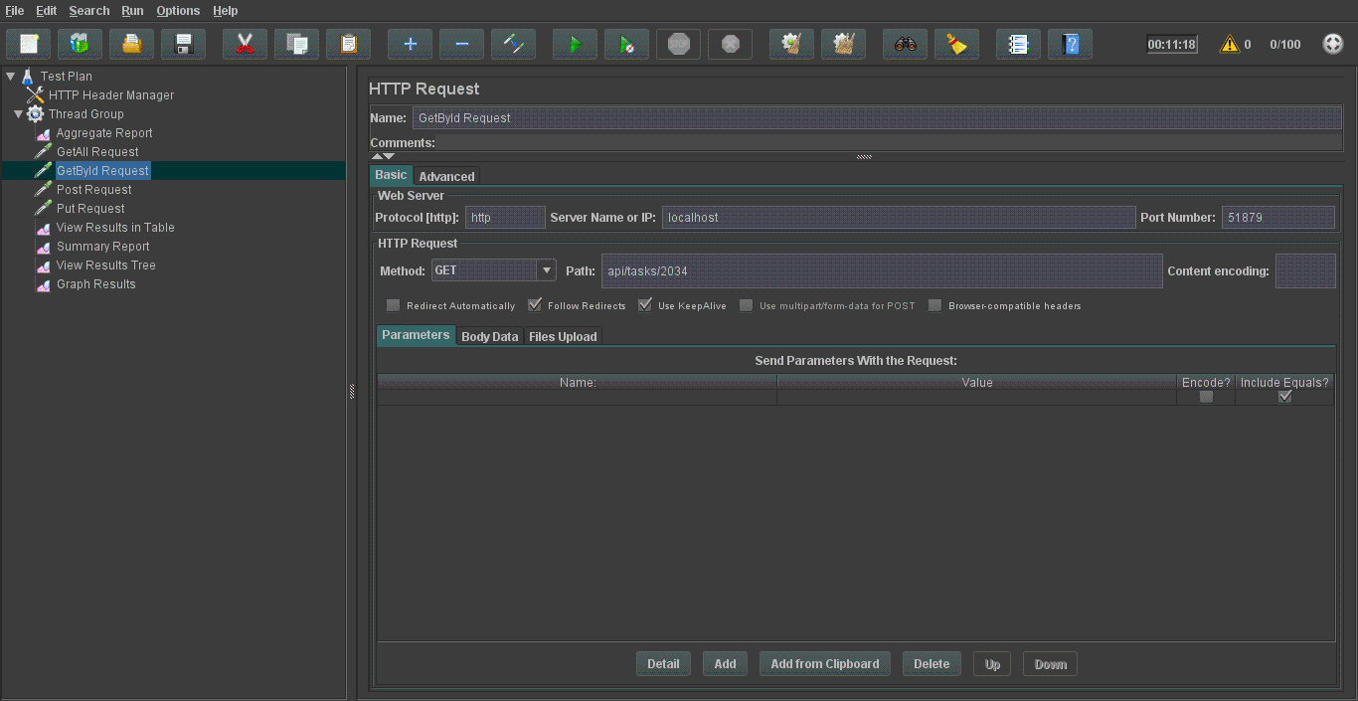

**Post Request to add a new task:**

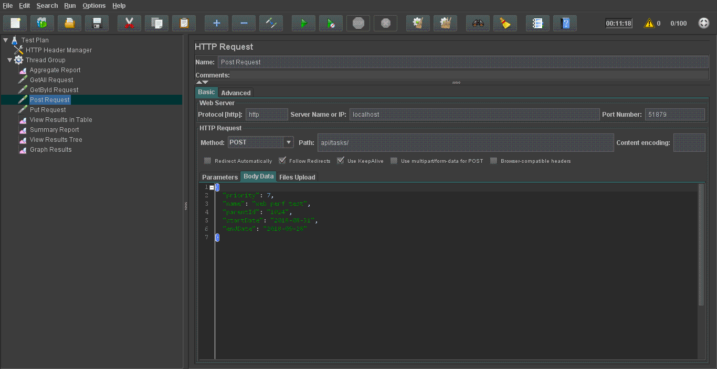

**Put Http request to edit a task**

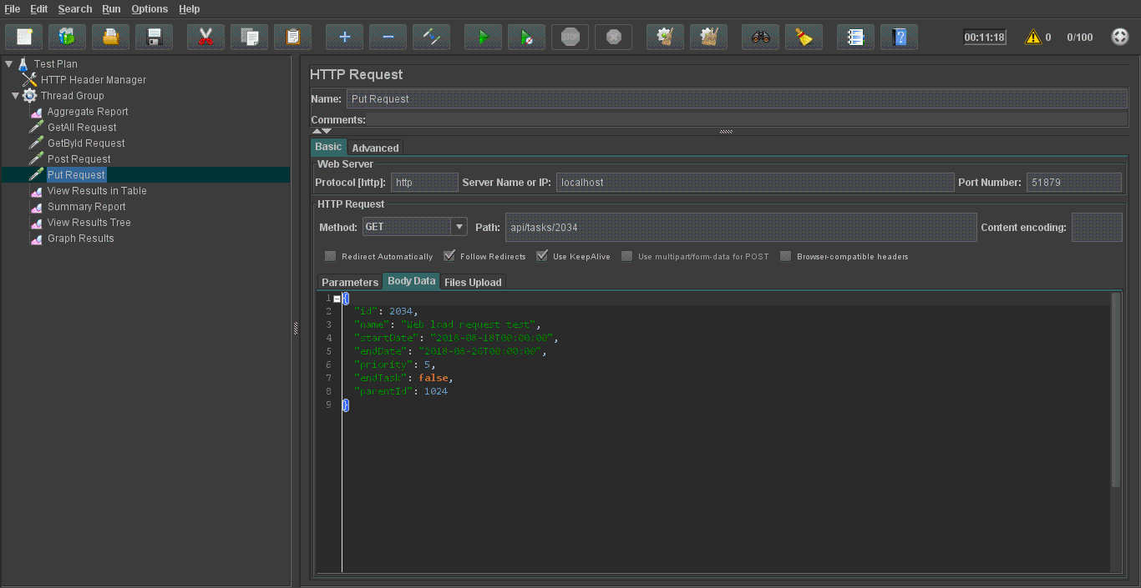

**Summary Test Report:**

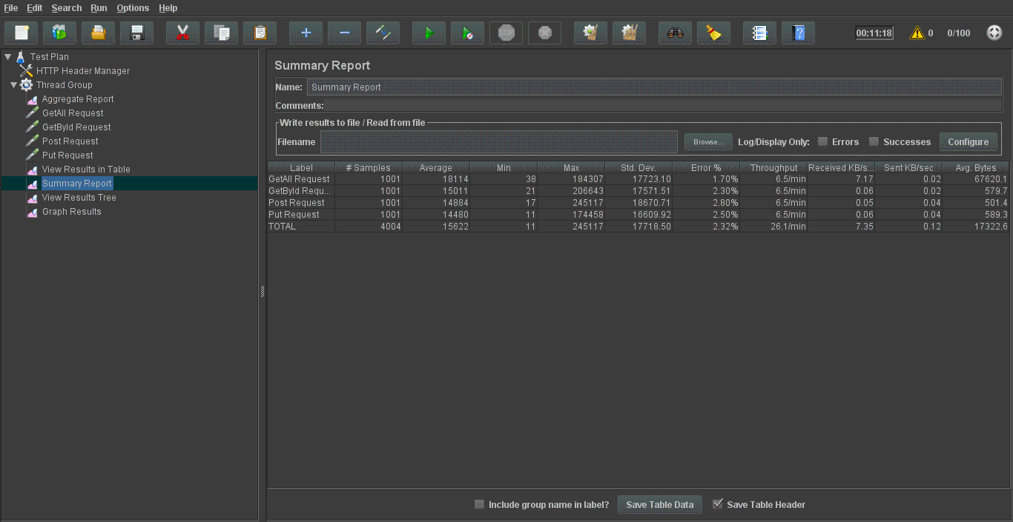

**View Result:**

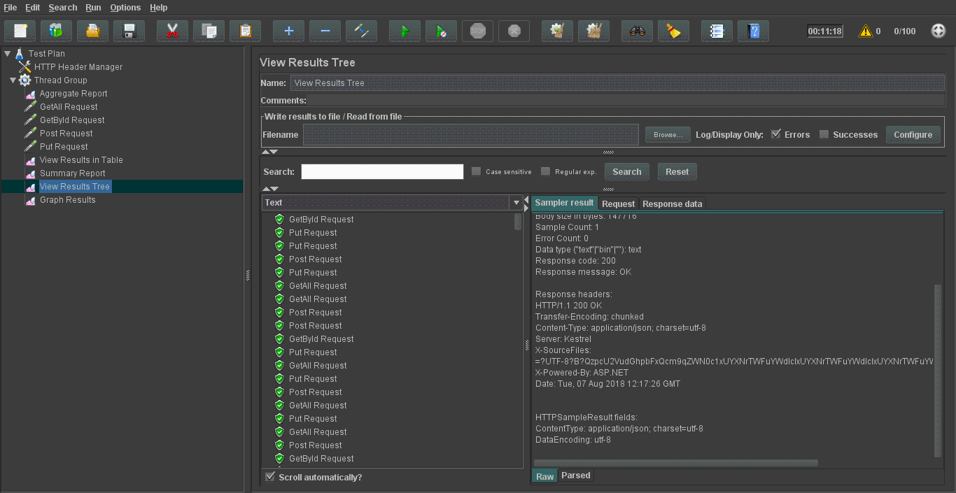

**Graph Result:**

